REAL TIME DEVSECOPS BINGO APP PROJECT| Infrastructure WITH TERRAFORM AND JENKINS CICD PIPELINE |END TO END DEVOPS PROJECT |

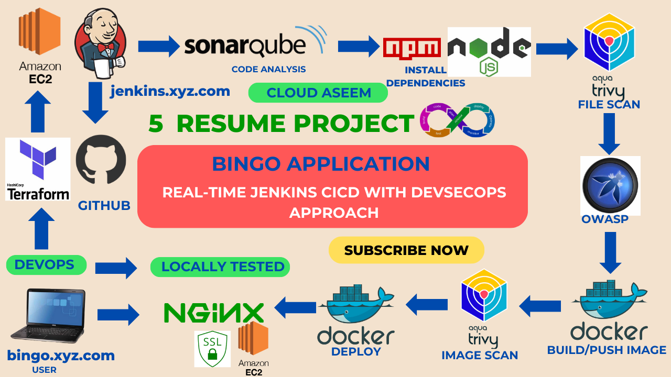6
project was to learn how to use web sockets and how to create a multiplayer game. It was created using Next.js, React and Sockets.io

Jenkins user = bingouser
Password = bingouser

Sonarqube = bingouser password
Jenkins integration
squ_02c240a69b9d0045e7043b3f38ce3917c73cad4e

sonar-scanner \
-Dsonar.projectKey=Bingo \
-Dsonar.sources=. \
-Dsonar.host.url=http://65.0.102.160:9000 \
-Dsonar.login=squ_02c240a69b9d0045e7043b3f38ce3917c73cad4e
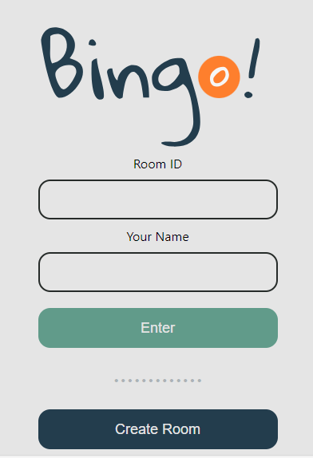
- Enter the room with the new details

RoomId : testgame

Your Name : aseem
localhost:3000/testgame?name=aseem
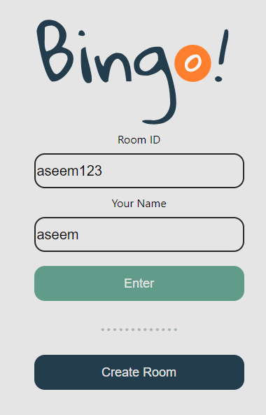

If there is no name of the room is exists , it prompt to create a room
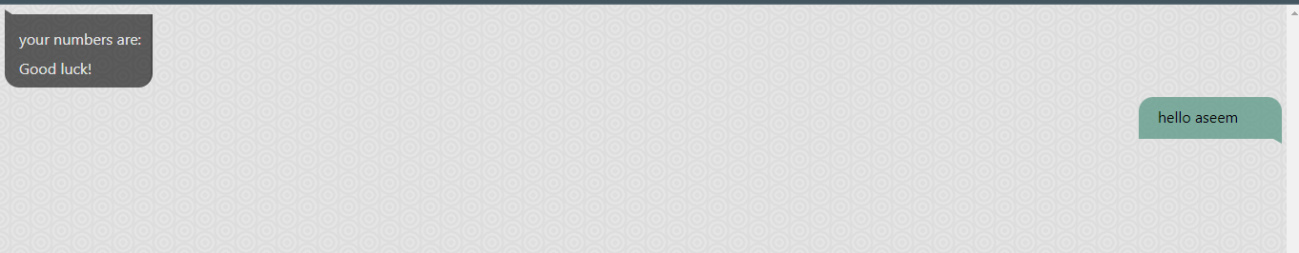
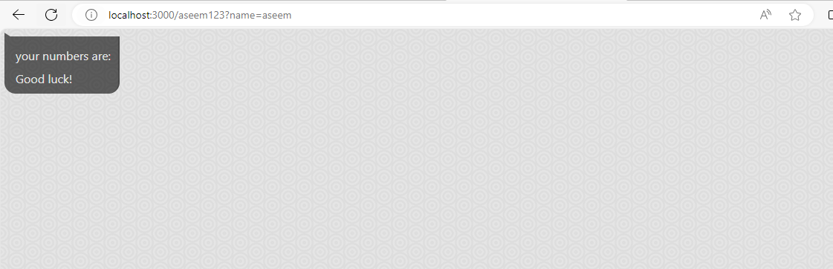

Client side :
Chat ID , opens with RoomID and Name
Server Side :
In the application backend logs creates successfully
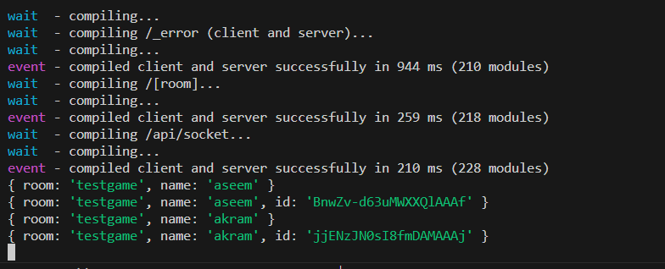
Login with RoomID with your another user
http://localhost:3000/testgame?name=akram
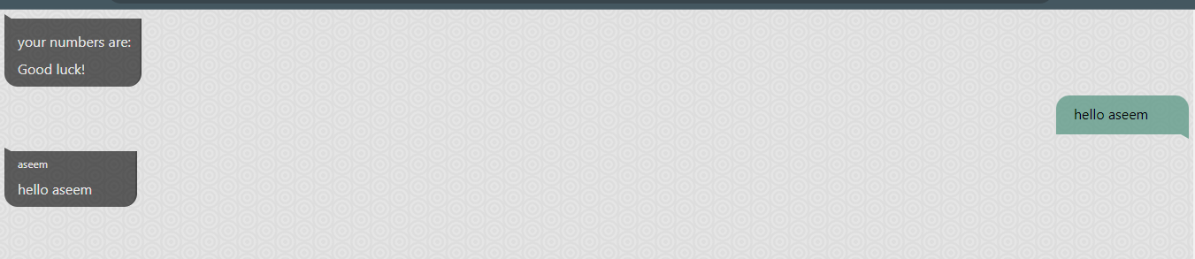
Table of contents
COMPLETE PROJECT VIDEO ON YOUTUBE
Step1: Create directory
Step2: Aws Configure
Step3: Terraform files and Provision Jenkins,sonar
Step 4 — Install Plugins like JDK, Sonarqube Scanner, NodeJs, OWASP Dependency Check
4A — Install Plugin
4B — Configure Java and Nodejs in Global Tool Configuration
Step 5 — Configure Sonar Server in Manage Jenkins
Step 6 — Install OWASP Dependency Check Plugins
Step 7 — Docker Image Build and Push
Embark on a thrillint DevSecOps adventure with our latest project - a real-time Bingo app! 🎉 In this comprehensive tutorial, we'll guide you through the entire lifecycle, from building a robust infrastructure using Terraform to implementing a seamless CI/CD pipeline with Jenkins. 🏗️ Infrastructure with Terraform: Witness the power of Terraform as we construct a scalable and secure environment for our Bingo app. Explore the intricacies of infrastructure as code (IaC) and learn how Terraform streamlines the deployment process. 🔒 DevSecOps Best Practices: Dive deep into the world of DevSecOps with a focus on security. Discover how we integrate Trivy to scan Docker images and containers, ensuring that our app remains fortified against vulnerabilities. We'll also conduct OWASP dependency checks, implement SSL for enhanced encryption, and configure NGINX for optimal web server performance. 🔄 Jenkins CI/CD Pipeline: Join us as we set up a robust Jenkins CI/CD pipeline to automate the entire development lifecycle. Witness the magic of continuous integration as Jenkins builds, tests, and packages our Bingo app. Learn how to seamlessly deploy the app locally for testing and, ultimately, on a server for real-world usage. 👩‍💻 Resume Project Building Locally: Get hands-on experience as we guide you through the process of building the Bingo app on your local machine using Jenkins CI/CD. Understand the nuances of local testing, debugging, and troubleshooting to ensure a smooth development experience. 🚀 Deploy on Server: Witness the culmination of our DevOps journey as we deploy the Bingo app on a production server. Learn the essential steps to ensure a secure and efficient deployment, including best practices for server configuration and maintenance. 🚨 Don't miss out on this immersive tutorial that combines the best of DevOps and Security practices. Elevate your skills and take your DevSecOps game to the next level with our Real-Time DevSecOps Bingo App Project! 🌐💻 #DevSecOps #Terraform #Jenkins #CI/CD #DevOpsProject #BingoApp #SecurityFirst
COMPLETE PROJECT VIDEO ON YOUTUBE
https://www.youtube.com/watch?v=fGaGf3X3s6Q
COMPLETE PROJECT VIDEO ON YOUTUBE to install Terraform and Aws cli
Terraform Series Day – 04
https://www.youtube.com/watch?v=Gbyx1dNQyKQ
GITHUB LINK
https://github.com/Aseemakram19/bingo1.git
- Testing locally 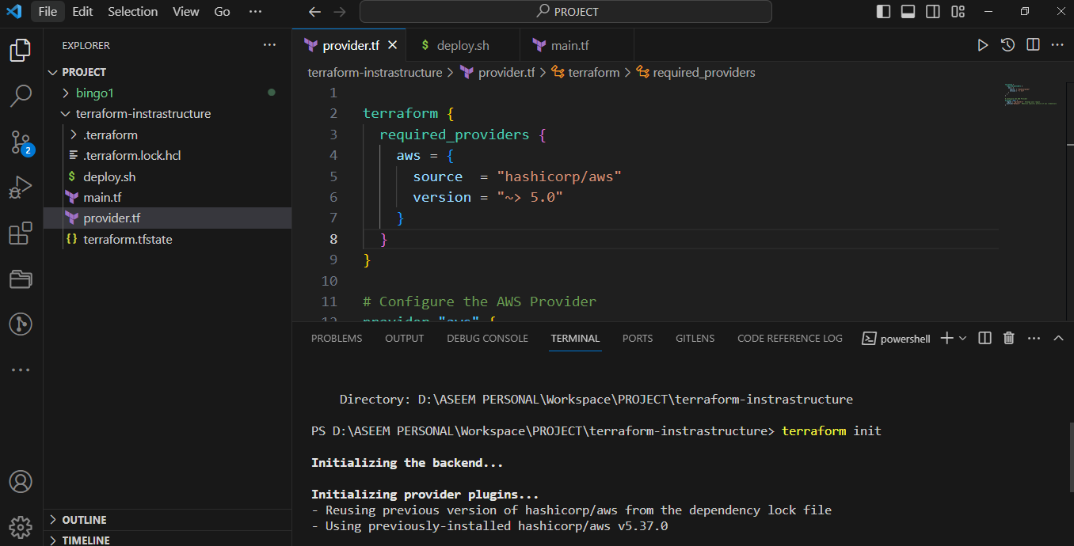
terraform apply
Prompt you to confirm the apply to create resource , enter the value “yes”
Or else use command to create without prompting the action
terraform apply --auto-approve 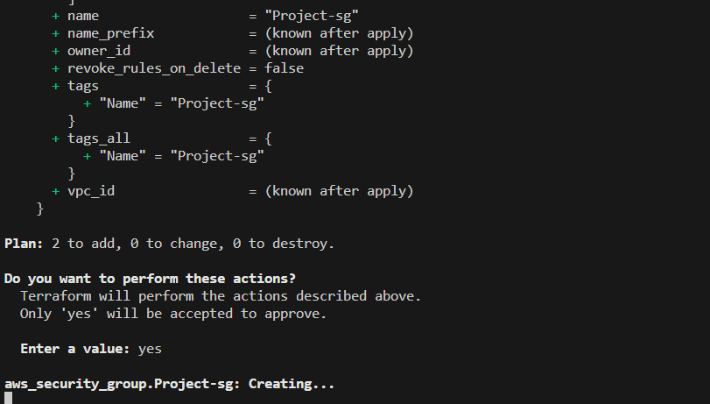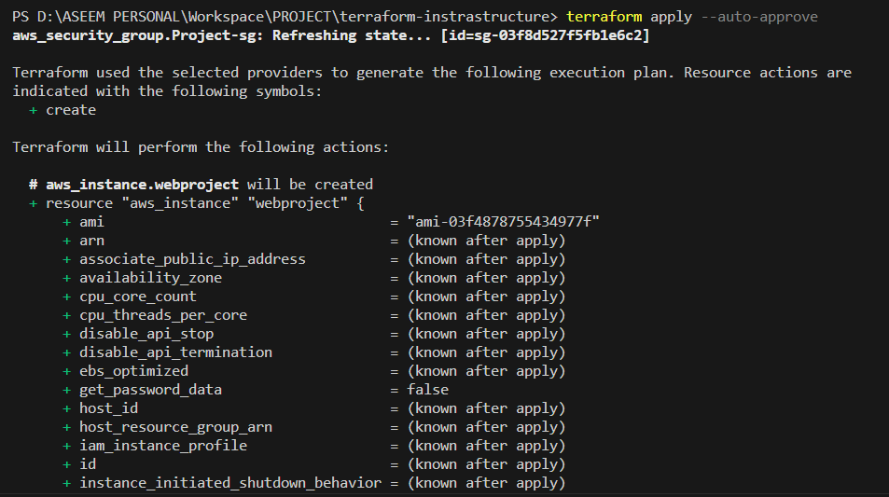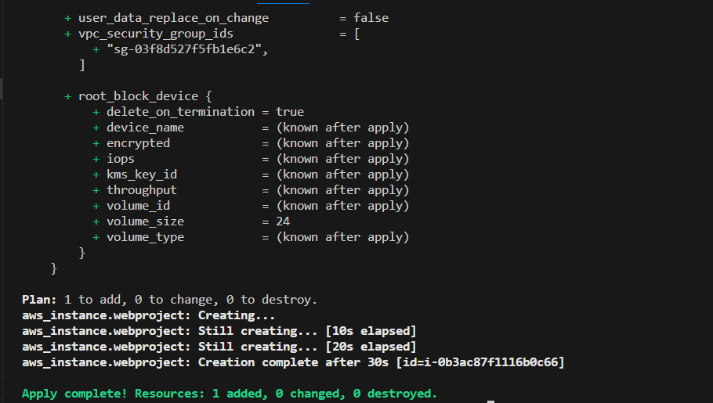

Resources has been created validate with IP:8080 for jenkins
#Login to server with credentials , set the hostname with following command
Resources has been created validate with IP:8080 for jenkins
1. Jenkins 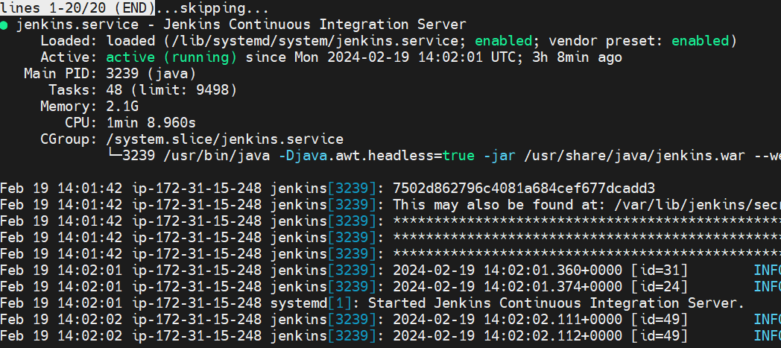

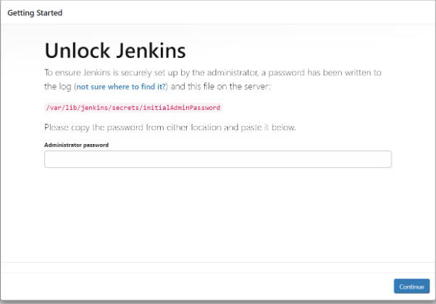

sudo cat /var/lib/jenkins/secrets/initialAdminPassword
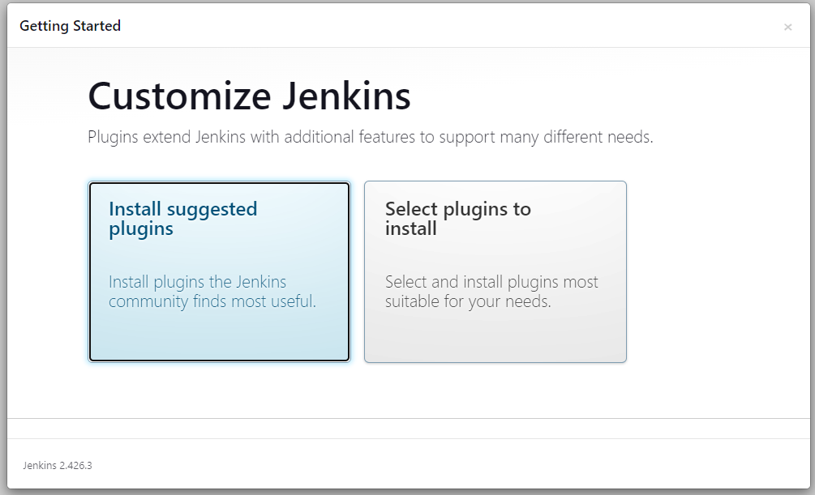

Click on install suggested plugin default.
Create a user click on save and continue.

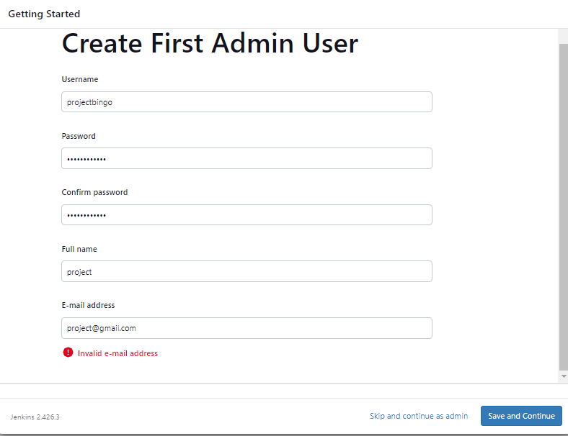
projectbingo as new password
Copy your Public key again and paste it into a new tab
<instance-public-ip:9000>
Now our sonarqube is up and running

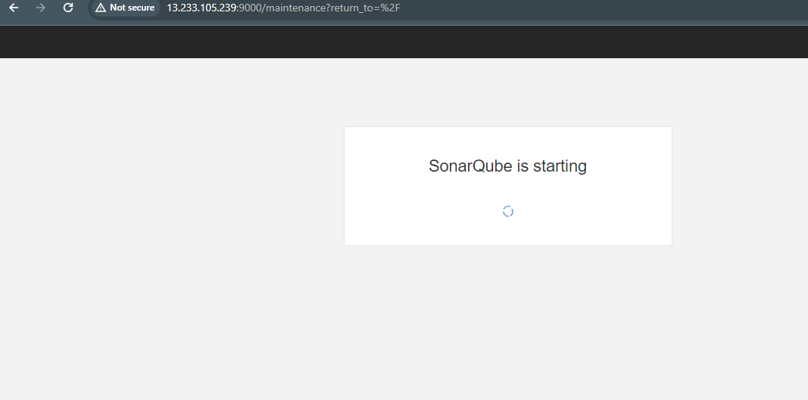

Enter Default username and password, click on login and change password
username admin
password admin
projectbingo as new password

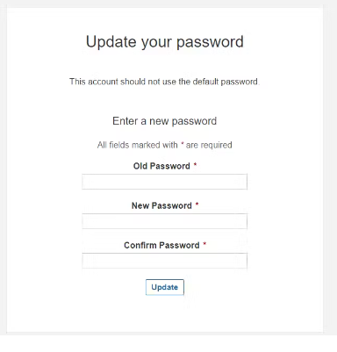

projectbingo as new password
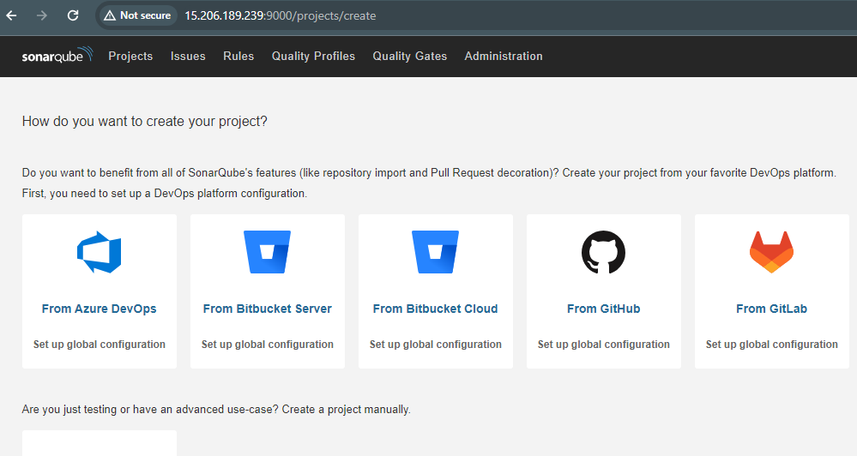
Check trivy version
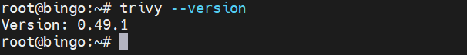

Install Plugins like JDK, Sonarqube Scanner, NodeJs, OWASP Dependency Check
Goto Manage Jenkins →Plugins → Available Plugins →
Install below plugins
1 . Eclipse Temurin Installer (Install without restart)
2 . SonarQube Scanner (Install without restart)
3 . NodeJs Plugin (Install Without restart) – 16.20.2
4. OWASP Dependency Check Plugins
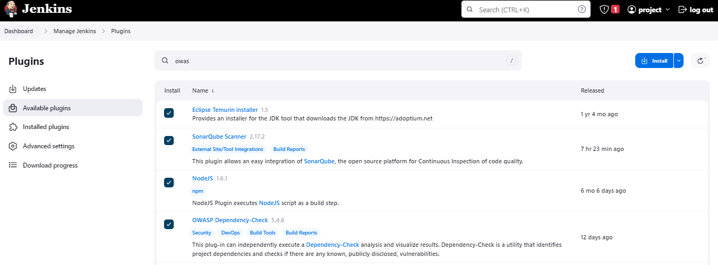
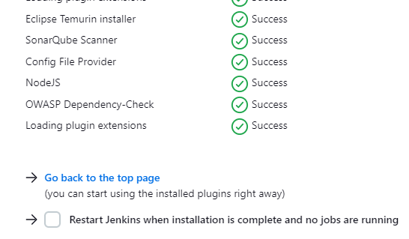
We need to install the Docker tool in our system, Goto Dashboard → Manage Plugins → Available plugins → Search for Docker and install these plugins
1. Docker
2. Docker Commons
3. Docker Pipeline
4. Docker API
5. docker-build-step

and click on install without restart
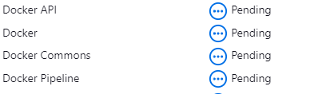

Now, goto Dashboard → Manage Jenkins → Tools →
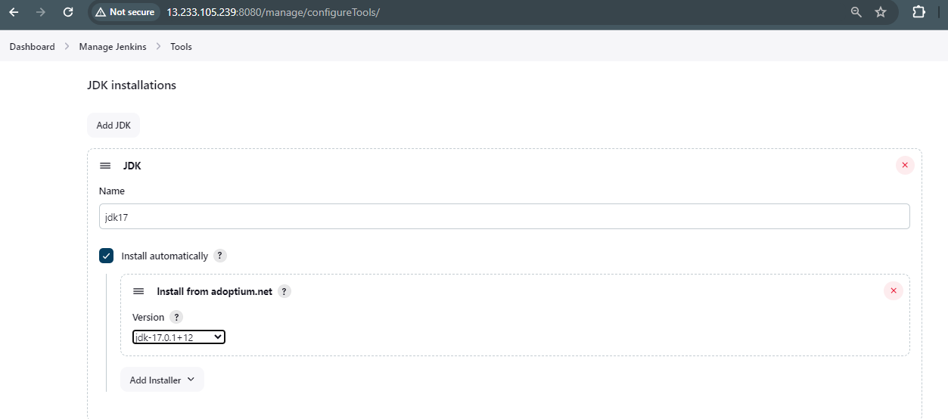

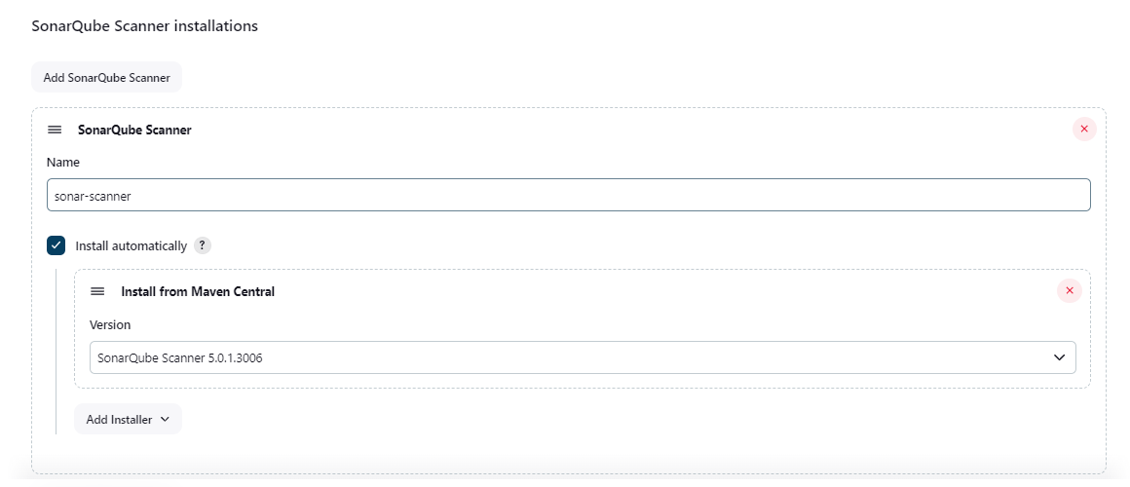
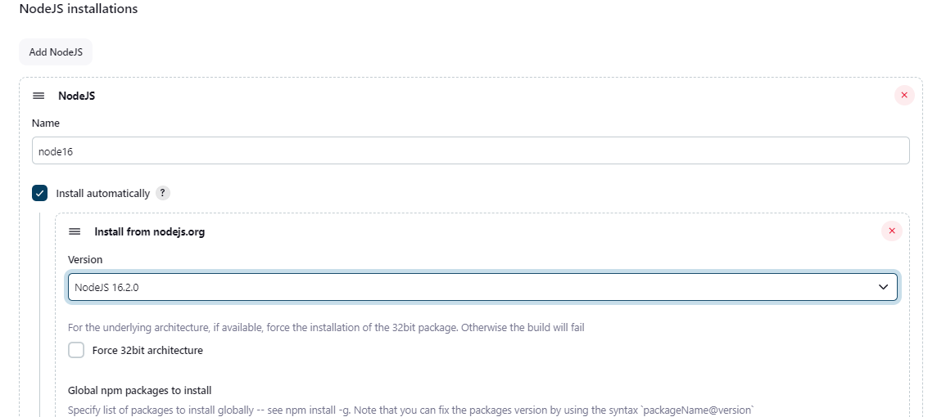16.20.2
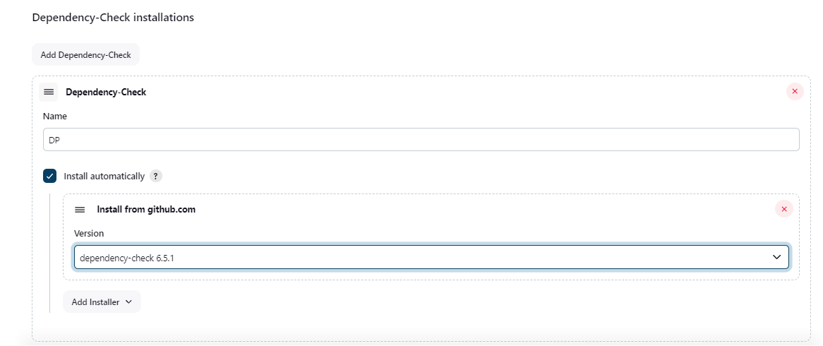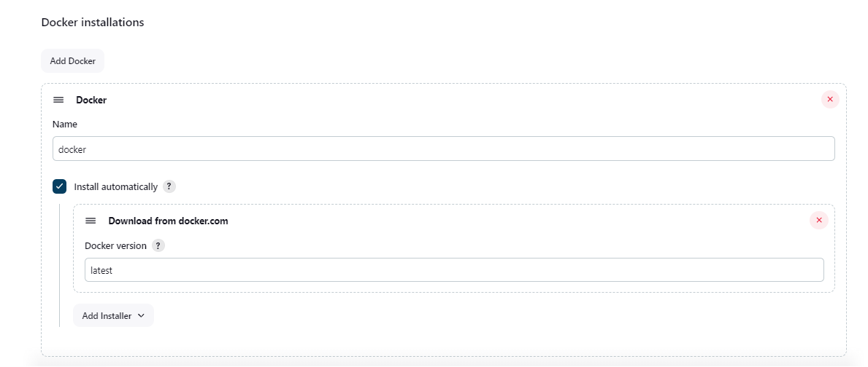

Apply & save the setting
SonarQube token
Click on Administration & security & user then click on right 3 dot to create new token
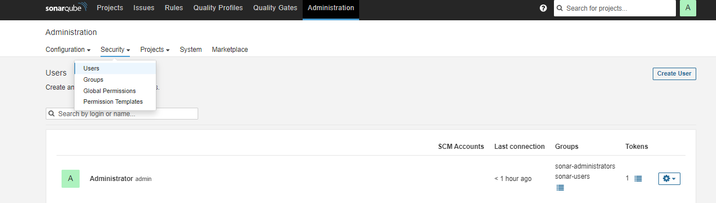
Sonar token for jenkins integration
squ_3dbc5694e44abae809628a88fb49ee082da32dff
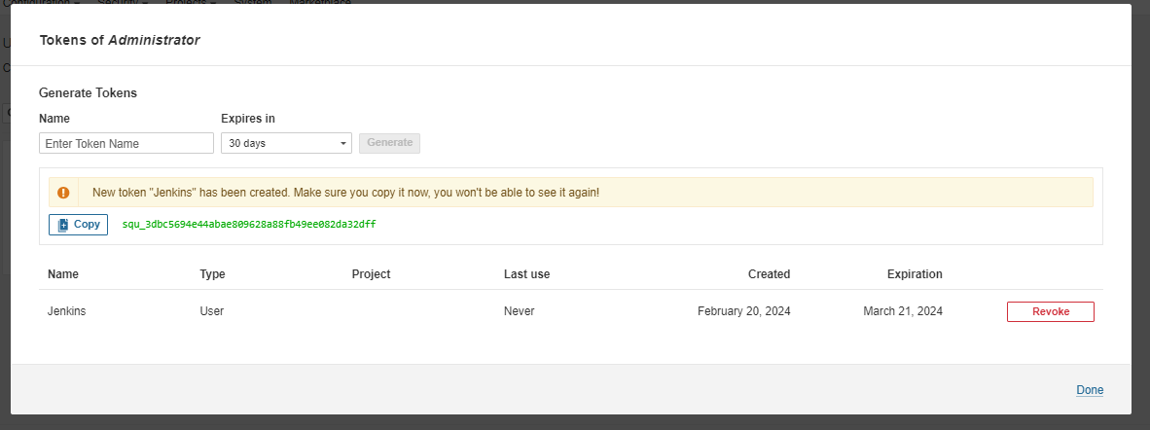
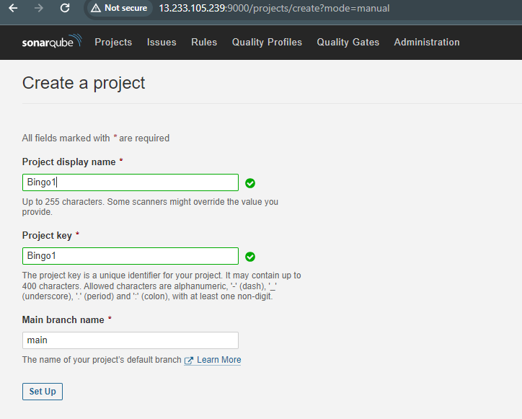

Click on setup , click on locally , provide the token
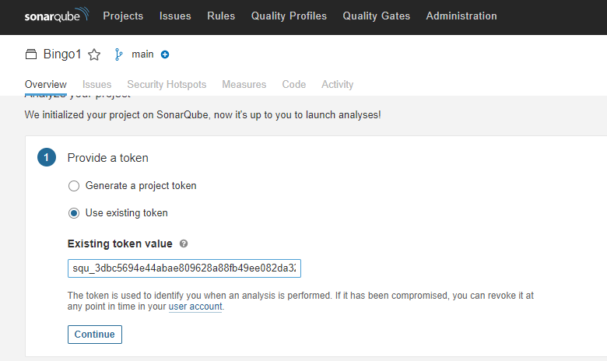

sonar-scanner \
-Dsonar.projectKey=Bingo1 \
-Dsonar.sources=. \
-Dsonar.host.url=http://13.233.105.239:9000 \
-Dsonar.login=squ_3dbc5694e44abae809628a88fb49ee082da32dff

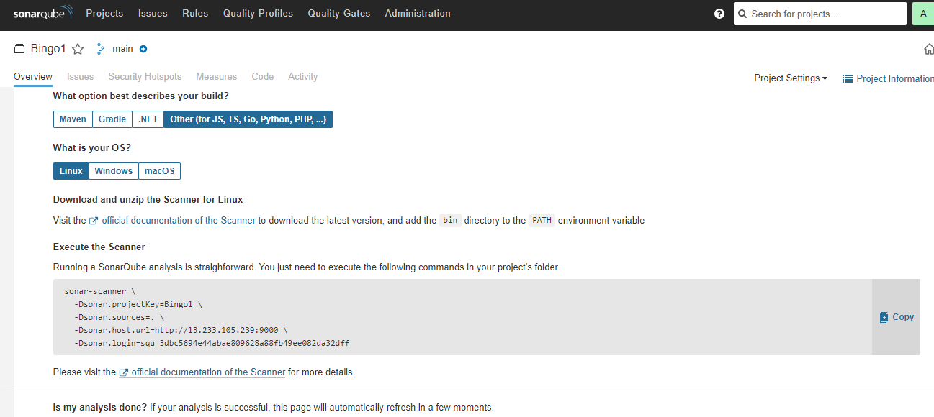
Jenkins in order to add SonarQube token in Jenkins credentials sections 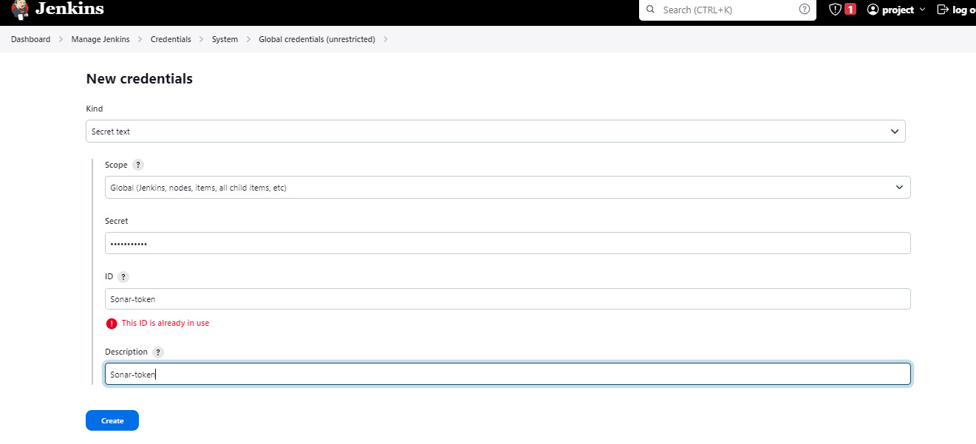

Quality Gate
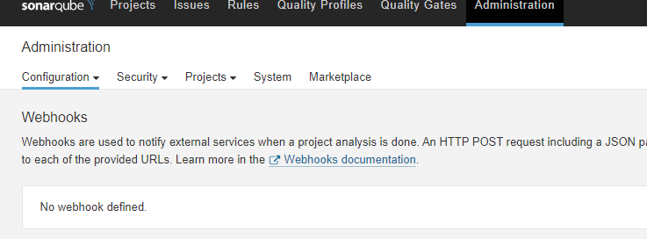

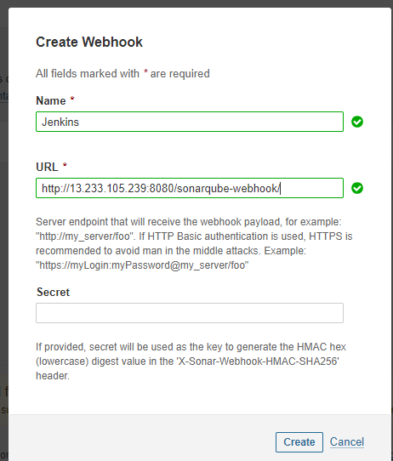

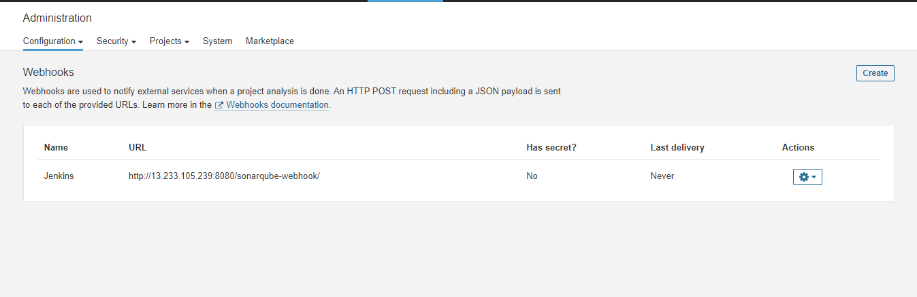
Configure the sonarqube server
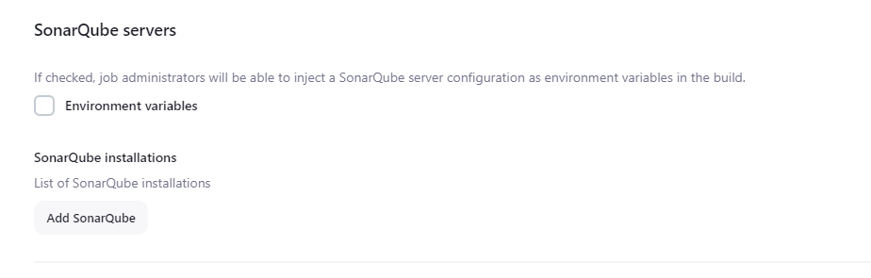
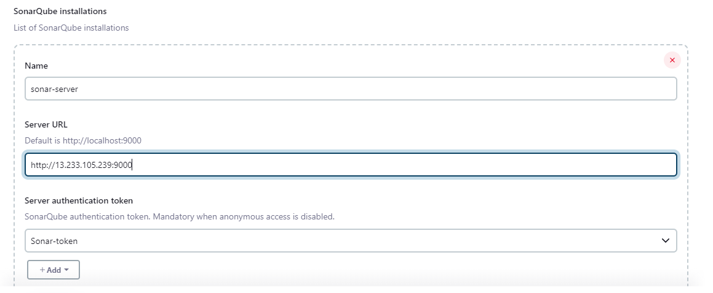
Create new pipeline in for bingo project
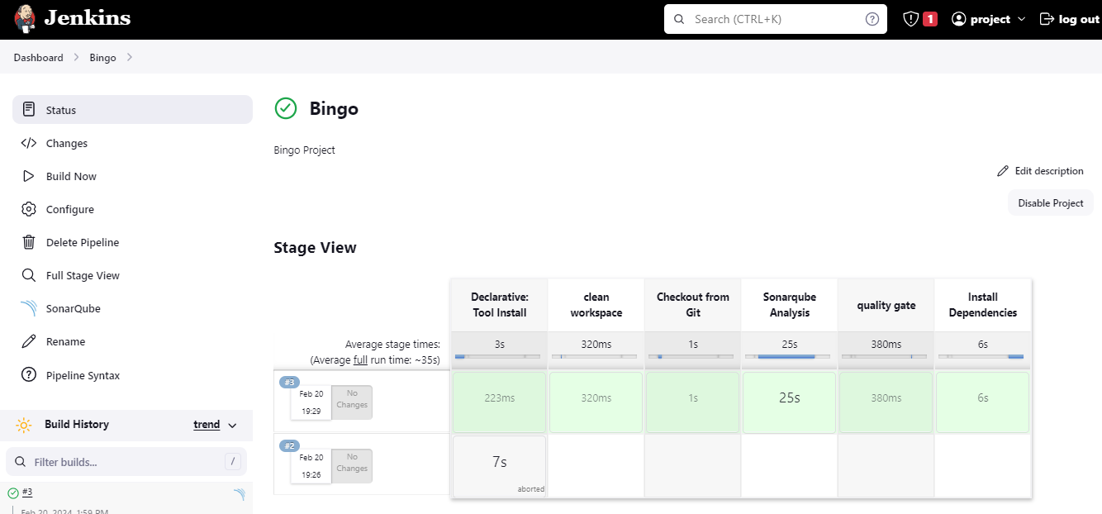
pipeline{
agent any
tools{
jdk 'jdk17'
nodejs 'node16'
}
#environment {
#SCANNER_HOME=tool 'sonar-scanner'
#}
stages {
stage('clean workspace'){
steps{
cleanWs()
}
}
stage('Checkout from Git'){
steps{
git branch: 'main', url: 'https://github.com/Aseemakram19/bingo1.git'
}
}
stage("Sonarqube Analysis "){
steps{
withSonarQubeEnv('sonar-server') {
sh ''' $SCANNER_HOME/bin/sonar-scanner -Dsonar.projectName=Bingo \
-Dsonar.projectKey=Bingo '''
}
}
}
stage("quality gate"){
steps {
script {
waitForQualityGate abortPipeline: false, credentialsId: 'Sonar-token'
}
}
}
stage('Install Dependencies') {
steps {
sh "npm install"
}
}
}
}

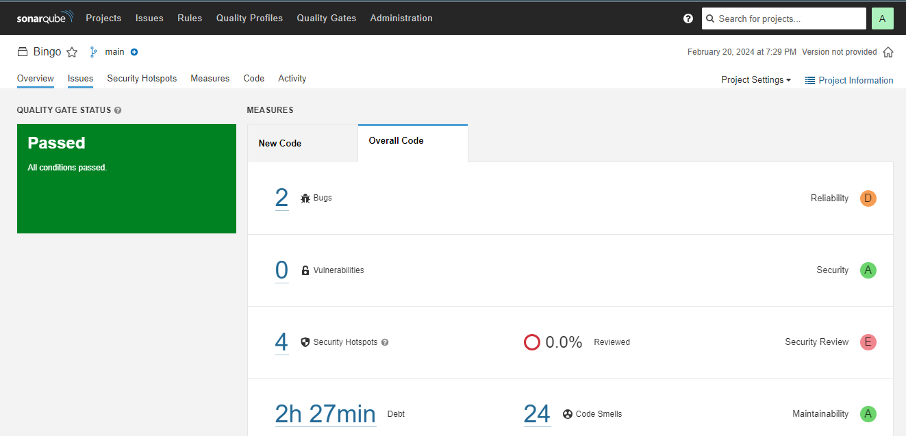

Add remaining tools checks in our pipelines , Now go configure → Pipeline and add this stage to your pipeline and build.
OWASP Dependency-Check is an open-source tool that identifies project dependencies and checks if there are any known, publicly disclosed, vulnerabilities in those dependencies. It is part of the Open Web Application Security Project (OWASP) and is designed to help organizations and developers identify and mitigate security risks related to third-party libraries and components used in their software projects.
Key aspects of OWASP Dependency-Check:
- Identification of Vulnerabilities:
  - Dependency-Check analyzes project dependencies, including libraries, frameworks, and components.
  - It checks these dependencies against a database of known vulnerabilities, including the National Vulnerability Database (NVD) and other sources.
- Automatic Scanning:
  - Dependency-Check can be integrated into the development process and CI/CD pipelines.
  - It automatically scans dependencies to identify and report vulnerabilities, allowing for early detection and remediation.5
- Multiple Language Support:
  - Dependency-Check supports multiple programming languages and package managers, making it versatile for a wide range of projects.
  - It can analyze dependencies in Java, JavaScript, .NET, Python, Ruby, and more.
- Integration with Build Tools:
  - It integrates with popular build tools such as Maven, Gradle, npm, and others, making it easy to incorporate into existing development workflows.
- Usefulness:
  - Early Vulnerability Detection: Dependency-Check enables developers to identify and address security issues early in the development lifecycle.
  - Continuous Monitoring: It supports continuous monitoring of dependencies, helping to keep software secure over time as new vulnerabilities are discovered.
- Applicability:
  - Web Applications: Especially relevant for web applications where security vulnerabilities in dependencies can lead to serious security issues.
  - Any Software with Dependencies: Applicable to any software project that relies on third-party libraries or components.
- Complementary to SCA Practices:
  - Dependency-Check is part of Software Composition Analysis (SCA) practices, focusing on the security aspects of third-party software components.
- Open Source and Actively Maintained:
  - As an open-source project, Dependency-Check benefits from community contributions and is actively maintained to keep the vulnerability database up-to-date.

stage('OWASP FS SCAN') {
steps {
dependencyCheck additionalArguments: '--scan ./ --disableYarnAudit --disableNodeAudit', odcInstallation: 'DP'
dependencyCheckPublisher pattern: '**/dependency-check-report.xml'
}
}
stage('TRIVY FS SCAN') {
steps {
sh "trivy fs . > trivyfs.txt"
}
}
Trivy is an open-source vulnerability scanner designed for containerized environments. Here's a breakdown of its key aspects:

What is Trivy?

Vulnerability Scanner: Trivy is primarily used as a vulnerability scanner, focusing on container images. It helps identify security vulnerabilities within the components (libraries, packages, dependencies) of containerized applications.
Container Security: Trivy is specifically tailored for container security, making it a valuable tool in DevSecOps (Development, Security, and Operations) workflows. It's commonly used with container orchestration platforms like Kubernetes and containerization technologies like Docker.
Why use Trivy?

Early Detection of Vulnerabilities: Trivy aids in the early detection of vulnerabilities in container images. By scanning container images during the development and CI/CD (Continuous Integration/Continuous Deployment) processes, security issues can be addressed before deployment, reducing the risk of exposing vulnerabilities in production.
Automation: Trivy supports automation, allowing developers and DevOps teams to integrate vulnerability scanning seamlessly into their CI/CD pipelines. This ensures that security checks are part of the automated build and deployment processes.
Where is Trivy used?

Containerized Environments: Trivy is primarily used in containerized environments, where applications are packaged along with their dependencies into containers. This includes popular containerization platforms such as Docker and container orchestration systems like Kubernetes.
DevSecOps Pipelines: Trivy is integrated into DevSecOps pipelines to automate security checks throughout the software development lifecycle. It helps teams identify and remediate vulnerabilities early in the development process.
Security Audits: Trivy can be used for regular security audits of container images in production environments. This ongoing monitoring helps ensure that the deployed containers remain secure against the latest vulnerabilities.
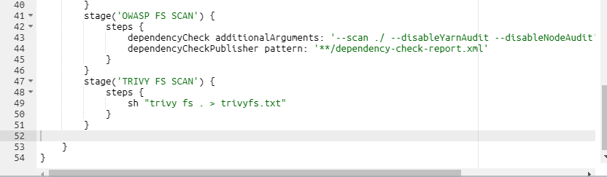

Build now the pipeline

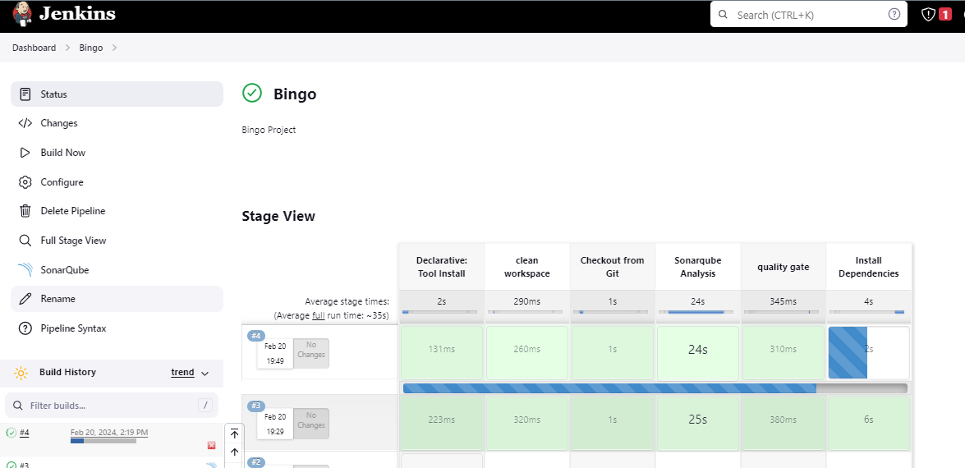
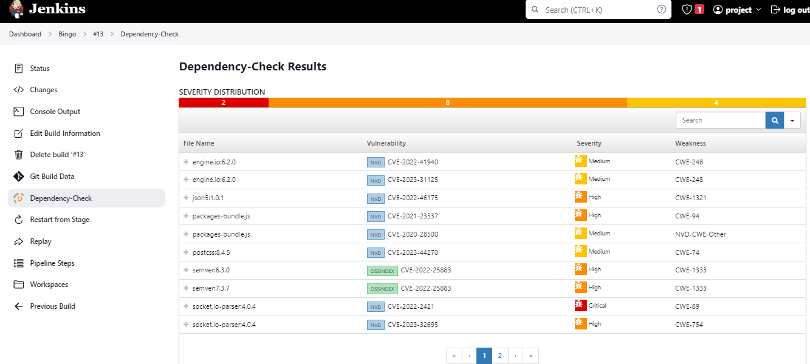

Go to docker hub & created a access token to integrate with Jenkins for Docker build & docker Push ,& docker pull to deploy
https://hub.docker.com/
Add docker credentials in credentials
Username – ##########
Password - ##########

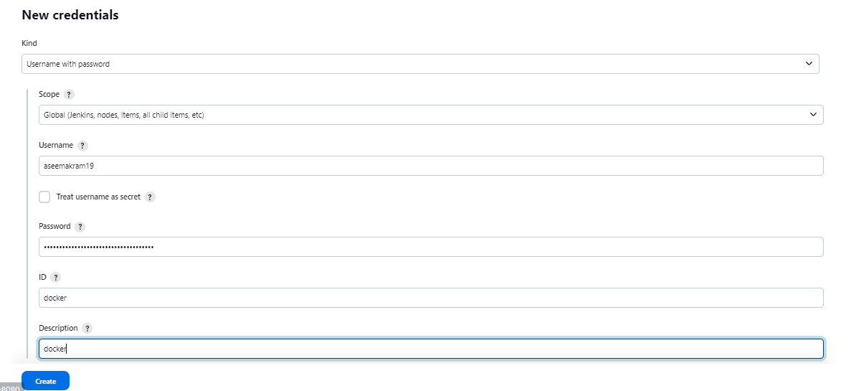
Add this stage to Pipeline Script
stage("Docker Build & Push") {
steps {
script {
withDockerRegistry(credentialsId: 'docker', toolName: 'docker') {
sh "docker build -t bingo ."
sh "docker tag bingo aseemakram19/bingo:latest "
sh "docker push aseemakram19/bingo:latest "
}
}
}
}
stage("TRIVY"){
steps{
sh "trivy image aseemakram19/bingo:latest > trivyimage.txt"
}
}
You will see the output below, with a dependency trend.
Now Run the container to see if the bingo app is live with adding the below stage
